Let your clients know how you can support them with their
15th January provisional tax payment

Social Media / Newsletter – OPTION 1:
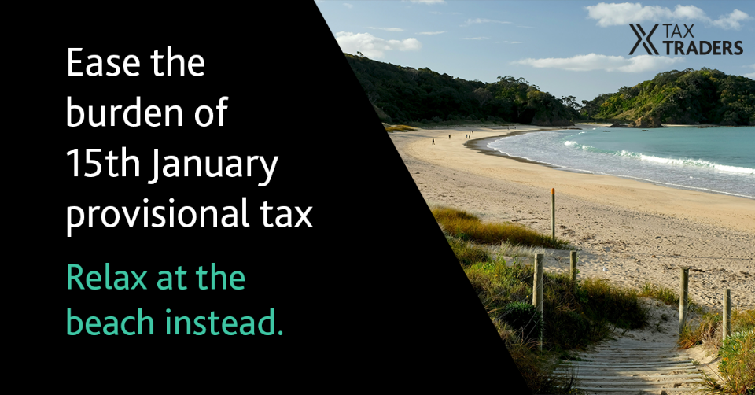
Tight cash flow in January? Provisional tax doesn’t have to be part of the problem.
Through our partnership with Tax Traders, you can defer your 15th January 2024 provisional tax payment to as late as June 2025. The process is enabled by IRD legislation and is trusted by thousands of taxpayers each year. It’s a great way to get some breathing space and keep cash on hand to support your business over the holiday period and can be set up in a matter of minutes. Talk to us to find out how easy it is.
[insert your firm’s contact info]
Social Media / Newsletter – OPTION 2:
Take the pressure off your 15th January 2024 provisional tax payment by delaying your payment by up to 17 months. With a financing arrangement through Tax Traders, you can eliminate IRD late payment penalties and save on use of money interest. The process is enabled by IRD legislation and is trusted by thousands of taxpayers each year. We can set this up for you in minutes, so you can relax over the holiday period. Talk to us to find out how easy it is.
[insert your firm’s contact info]
EDM/Newsletter article:
Take the pressure off 15 January provisional tax
January can be a tight cash flow month for many businesses, but provisional tax doesn’t need to be part of the problem. Through our partnership with Tax Traders, you can delay your provisional tax payment by up to 17 months and retain cash in your business for other priorities.
With a financing arrangement, you’ll eliminate Inland Revenue (IR) late payment penalties and save on use of money interest.
If you no longer need all the tax at the maturity date, there is no break fee, and you only have to pay for what you need. If you want to repay early or pay by instalment, you can do that, too.
We use Tax Traders – New Zealand’s leading progressive tax pool – as the facilitator. Tax Traders is an IR-approved tax pooling intermediary and are trusted by thousands of taxpayers each year.
We can set this up for you in minutes, so you can relax over the holiday period. Talk to us to find out how easy it could be.
[insert your firm’s contact info]

Letter [on your firm’s letterhead]:
Dear [personalised name]
January can be a tough cash flow month, but provisional tax doesn’t have to be part of the problem.
Through our partnership with Tax Traders, you can defer your 15 January 2024 tax payment to as late as June 2025. The process is enabled by Inland Revenue (IR) legislation and is trusted by thousands of taxpayers each year.
How does it work? Simply pay the interest up front and then pay your provisional tax at a maturity date of your choice up to 17 months later. The provisional tax is held for you in a Public Trust account at IR and is transferred to your IR account at maturity, once your provisional tax is paid.
If you no longer need all the tax at the maturity date, there’s no break fee, and you only have to pay for what you need. If you want to repay early or pay by instalment, you can do that, too.
This is a great way to get some breathing space and keep cash on hand to support your business over the holiday period and can be set up in a matter of minutes.
Talk to us to find out how easy it could be.
Kind regards,
[Partner name]

